ABSTRACT: All the authors must use this template for preparing the abstract. Authors of abstract have to type these in a form suitable for direct photographic reproduction by the publisher. In order to ensure uniform style throughout the volume, all the abstracts have to be prepared strictly according to the instructions below. For the convenience of the authors template files for MS Word 6.0 (and higher) are provided. This part is for the brief explanation of the presented study and should not exceed 100 words.
Template for the two-page extended abstract for the 8th APRU Research Symposium (Times New Roman, 16 point)
1st. Author (Times New Roman 12 point)
Graduate school of engineering, Japan University, Japan (Times New Roman 12 point, italic)
2nd. Author
Faculty of geological sciences, Japan University, Japan

- 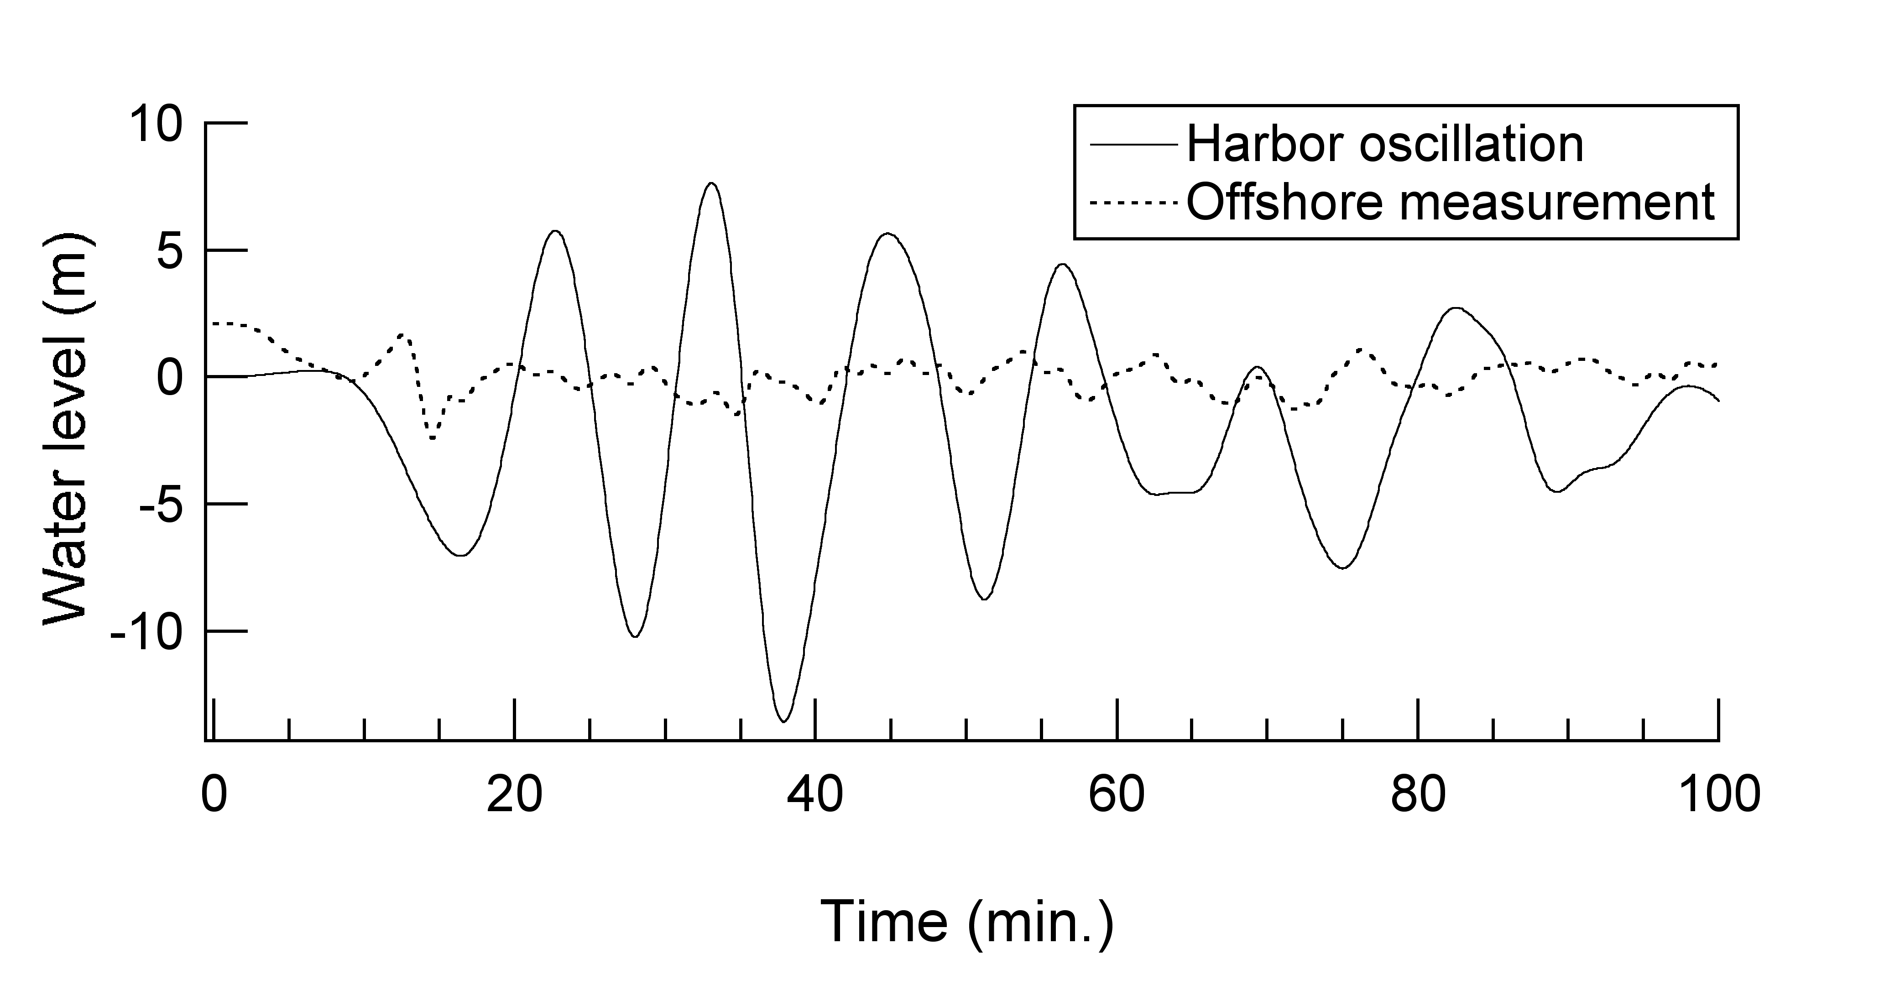General Instructions
Figure 1. Caption of a typical figure.

  - Typefont, typesize and spacing
Use Times New Roman 10 point size and 14 point line spacing. Use roman type except for the headings, parameters in mathematics (not for log, sin, cos, ln, max., etc), Latin names of species and genera in botany and zoology and the titles of journals and books which should all be in italics.
Never use bold, except to denote vectors in mathematics. Never underline any text. Use the same or smaller font (10 points or 9 points) for tables, figure captions and the references.

- Layout of text
  - Equations
Use the equation editor of the selected word processing program. Equations are not indented. Number equations consecutively and place the number with the tab key at the end of the line, between parentheses. Refer to equations by these numbers. See for example Equation (1) below:

E = mc² (1)

For simple equations in the text, always use superscript and subscript (select Font in the Format menu). Do not use the equation editor in the text on same line.

  - Tables
Locate tables close to the first reference to them in the text and number them consecutively. Avoid abbreviations in column headings. Indicate units in the line immediately below the heading.

Table 1. Margin settings for A4 size paper.

Settings | A4 size paper (cm)
Top | 2.5
Bottom | 2.5
Left | 1.9
Right | 1.9

  - Figures and captions
Always use the Figure caption with 9 points size on 11 points line space. Place the caption underneath the figure. Type as follows: “Figure 1. Caption.” Leave about two lines of space between the figure caption and the text of the paper.

  - References
In the text, place the authors’ last names (without initials) and the year of publication in parentheses, e.g. Author (2012) or Author et al. (2012). At the end of the abstract, list all references in alphabetical order underneath the heading references. The references should be typed in smaller text (9 pt) and second and further lines should be indented. If several works by the same author are cited, entries should be chronological:
Larch, A.A. (1996a), Development ...
Larch, A.A. (1996b), Facilities ...
Larch, A.A. and Jensen, M.C. (1996), Effects of ...

- Abstract submission
Abstracts should be submitted no later than the submission dead line 8 August 2012. Authors will be notified of acceptance by 9 August 2012. The abstract should not exceed 2 pages including figures and tables.
The acceptable format is only .pdf. Convert the template file into .pdf format. Do not send .doc or any other formats. Abstract should be sent using the electronic submission form prepared at the symposium web site : http://irides.tohoku.ac.jp/event/apru2012/.
Each abstract must be submitted by presenter as corresponding author. The conveners will review abstracts for its contents and scientific merits. The review decision will be either "Accepted" or "Rejected". The reviewed results will be sent to corresponding author no later than 9 August, 2012.

- References
Grove, A.T. (1980), Geomorphic evolution of the Sahara and the Nile. In M.A.J. Williams & H. Faure, The Sahara and the Nile, 21-35.
Jappelli, R. and Marconi, N. (1997), Recommendations and prejudices in the realm of foundation engineering in Italy: A historical review, Geotechnical engineering for the preservation of monuments and historical sites, Proc. Intern. Symp., Napoli, 3-4 October 1996.
Johnson, H.L. (1965), Artistic development in autistic children. Child Development 65 (1), 13-16.

